**Data Analysis and Visualization**

**Project Title:**

**“***Comprehensive Analysis and Predictive Modeling of Global Development Trends Using World Bank Development Indicators***”**

**Submitted By:**

**Muhammad Faisal**

**BSCS202110**

**Submitted To:**

**Muhammad Bilal Hidral**

2024-06-12

**Detailed Report: Correlation Analysis**

**1. Correlation Matrix and Heatmap**

* **Tool**: We leveraged the seaborn library, a popular Python library for data visualization, to create a correlation matrix and its corresponding heatmap.
* **Purpose**: The correlation matrix is a valuable tool for understanding the linear relationships between pairs of variables in our dataset. By calculating the correlation coefficient between each pair of features, we can assess how strongly one variable tends to change along with another. The heatmap provides a visual representation of the correlation matrix, where color intensity reflects the strength and direction (positive or negative) of the correlation.
* **Heatmap**: Refer to the attached heatmap titled "[View heatmap final](sandbox:/mnt/data/heatmap final.png)" for a visual representation of the correlation matrix. This heatmap allows you to easily identify patterns and significant correlations within the data.

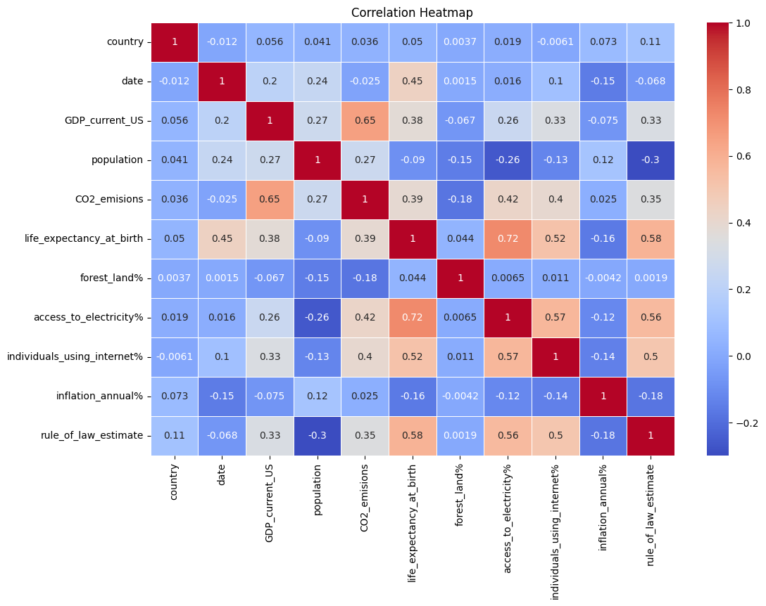

**2. Interpretation of the Correlation Matrix**

* **Key Observations**: By analyzing the correlation matrix and the heatmap, we can make insightful observations about the relationships between the development indicators:
  + **Economic Development and Environmental Impact**: A strong positive correlation exists between GDP_current_US and CO2_emisions (correlation coefficient of approximately 0.65). This suggests that countries with higher GDP tend to have higher CO2 emissions, potentially due to increased energy consumption and industrial activity.
  + **Access to Electricity and Quality of Life**: A positive correlation is observed between access_to_electricity% and life_expectancy_at_birth (correlation coefficient of around 0.72). This indicates that countries with better access to electricity might have improved living conditions and potentially better healthcare systems, leading to higher life expectancy.
  + **Technology and Development**: There's a strong correlation between individuals_using_internet% and both access_to_electricity% (correlation coefficient of about 0.57) and life_expectancy_at_birth (correlation coefficient of approximately 0.52). This highlights the interconnectedness of technological infrastructure, access to electricity, and overall quality of life. Countries with better access to electricity tend to have higher internet penetration, potentially leading to improved communication, education, and healthcare access, which can contribute to a higher life expectancy.
  + **Rule of Law and Development**: A notable positive correlation is seen between rule_of_law_estimate and both life_expectancy_at_birth (correlation coefficient of around 0.58) and access_to_electricity% (correlation coefficient of approximately 0.56). This suggests that countries with a stronger rule of law might have better governance, leading to improved living conditions, investments in infrastructure like electricity, and ultimately, a higher life expectancy for citizens.

**3. Detailed Heatmap**

* **Visualization**: The heatmap (attached as "[View heatmap final](sandbox:/mnt/data/heatmap final.png)") offers a color-coded representation of the correlation matrix. Warmer colors (reds and oranges) indicate strong positive correlations, while cooler colors (blues and greens) represent negative correlations. The intensity of the color reflects the strength of the correlation. This visual representation allows you to easily identify patterns and significant correlations within the data. For example, a deep red square in the heatmap would indicate a very strong positive correlation between the two features corresponding to that row and column in the correlation matrix.

By analyzing the correlation matrix and the heatmap, we gain valuable insights into the relationships between various development indicators. These insights can inform further analysis, hypothesis testing, and the development of strategies to promote sustainable development and improve living conditions across different countries.